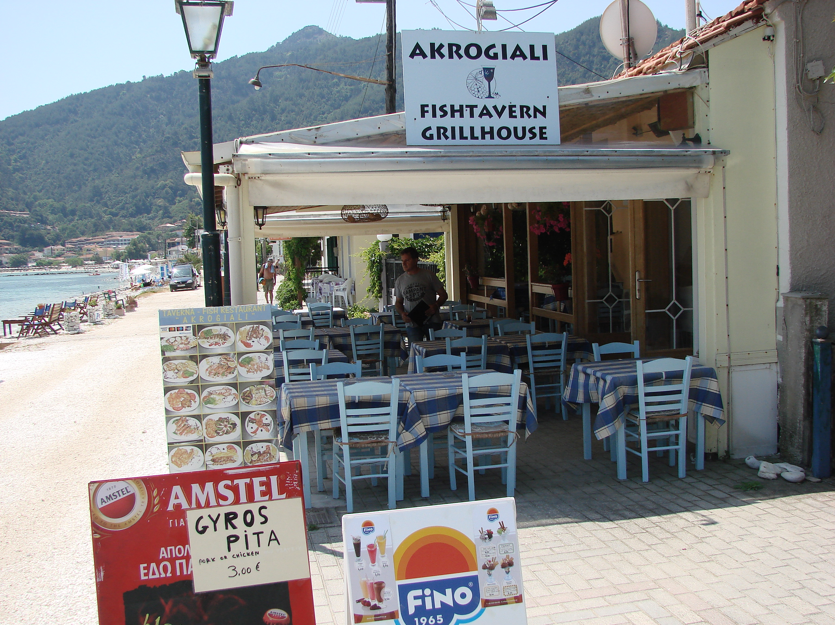
Prezentand acest voucher la restaurant beneficiati de o reducere de 10% din nota de plata. Voucherul poate fi folosit o singura data, fiind retinut de catre comerciant.
Nu pot fi folosite mai multe vouchere pentru a multiplica reducerea !

Presenting this voucher at the restaurant you benefit from a reduction of 10% of the bill.
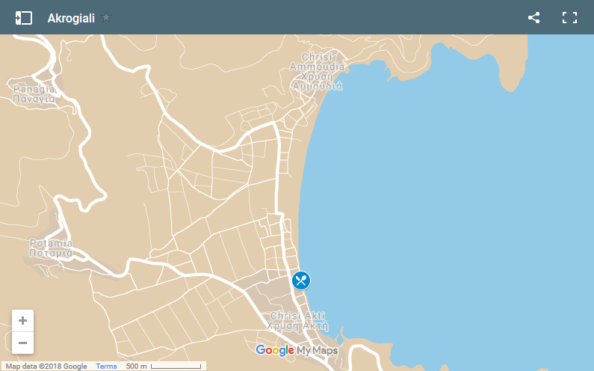
This voucher can be used only once, being retained by dealer.
You can't use more voucher to multiply the reduction !
Cod/e : 20AKRO19GIALI

